remind scenario | What | Mapping | Notes
SSP1-PkBudg650 | ambitious global mitigation effort and strong mitigation (~1.8°C) | ≈ SSP1-RCP1.9 | Previous version has SSP1- PkBudg500 but now it’s no longer available, so still it’s the beset match for SSP1-19  RCP19 = 1.5°C ≈ 400–500 GtCO2, and 650GtCO2 is less stringent though still the closest
SSP2-NDC | Paris NDCs (Nationally Determined Contributions)  until 2030, then flat | ≈ SSP2-RCP4.5 | RCP (~4.5 W/m² forcing in 2100) -> 2.4–2.8°C warming -> medium climate action, not Paris-aligned but not high-emissions
SSP5-NPi | No policies implementation | ≈ SSP5-RCP8.5 | best match

BUT remind SSP5-NPi errored when installing with newest premise v2.3.2, so switch to image
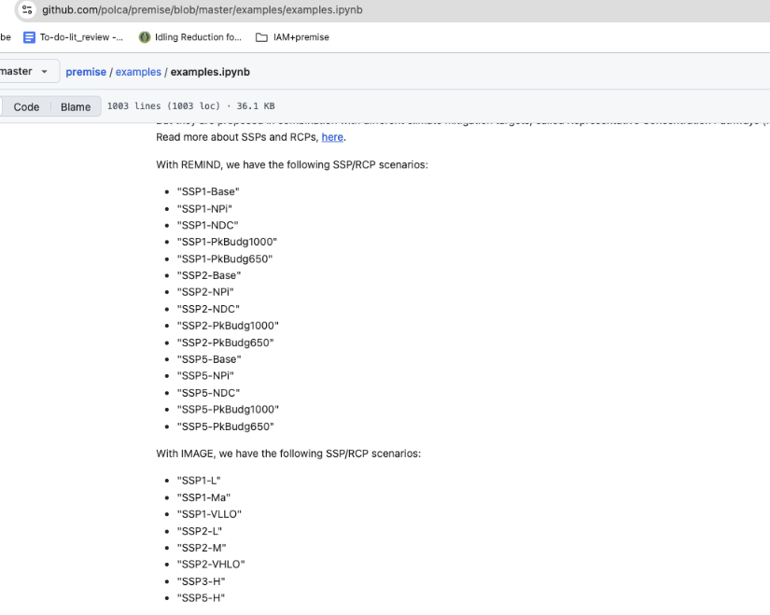
## Two hypothetical electricity market (a hydro-dominant vs. a coal-dominant):

Hydro vs. Wind offshore / Solar roof top PV

RQ: “How does the metric change potential policy reading of a coal-heavy vs hydro-heavy electricity system under different future decarbonisation scenarios?”

Option1. using historical trend from IEA – China vs. IEA – Canada, fitting linear functions
 | SSP1-RCP19 | SSP1-RCP19 | SSP1-RCP19 | SSP2-RCP45 | SSP2-RCP45 | SSP2-RCP45 | SSP5-RCP85 | SSP5-RCP85 | SSP5-RCP85
 | 2030 | 2040 | 2050 | 2030 | 2040 | 2050 | 2030 | 2040 | 2050
Hydro-dominant
(hydro-share%)
Coal-dominant
(coal-share%)

- We’ll use linear trend (follow historical trend) to compute the SSP2 % mixes
- Then SSP1/SSP5 with a hypothetical target %

### final absolute (SAME) demand:
So, to isolate the effect of supply mix and timing on dpGWP vs GWP, we assume identical electricity demand in the two hypothetical markets; differences in results arise solely from the evolution of their generation mix.
the cleanest setup is:
- Use % mixes (not absolute amount kWh):
  - Coal-dominant: coal%(t) built from China history + SSP1/2/5 rules.
  - Hydro-dominant: fossil%(t) (or hydro%(t)) built from Canada history + SSP1/2/5 rules.
- Then apply the same absolute demand path to both markets
  - Just a hypothetical demand path for our hypothetical region
- Then we fill the remainder with one same tech (nuclear [debatable … think about another tech??? ] which is neither CO2 nor CH4 dominant?) so that, the same “the other tech” is a neutral background; it cancels out when we compare metrics.

### after the hydro vs. coal system % + the remaining capacity % filled, we just pull from static ecoinvent to combine with this changing foreground %

Option2. No IEA historic data, everything just future premise mix, ### then hydro vs. coal% may not be as contrasting as option 1, but it’s more realistic/IAM-based?

Let’s compare SSP5/2050 [CH4 vs. CO2 flows]: coal vs. hydro vs. gas (CHP/) vs. nuclear (dpGWP vs. static GWP)

### even if with the premise%, we still define a hypothetical final absolute (SAME) demand for the two system, and same approach to fill in the remaining capacity by just one tech?

REAL case study:
Plot of different region of elec mix change -> dynamic LCI -> static vs. dpGWP…

## Future premise electricity market (real grid mix), no longer sharp difference on hydro vs. coal?
Then just apply static GWP, dpGWP to the same premise inventory, but what RQ? How can we really isolate CO2 vs. CH4?

IEA data accessed Nov21, 2025:

Canada – most updated 2024 electricity%
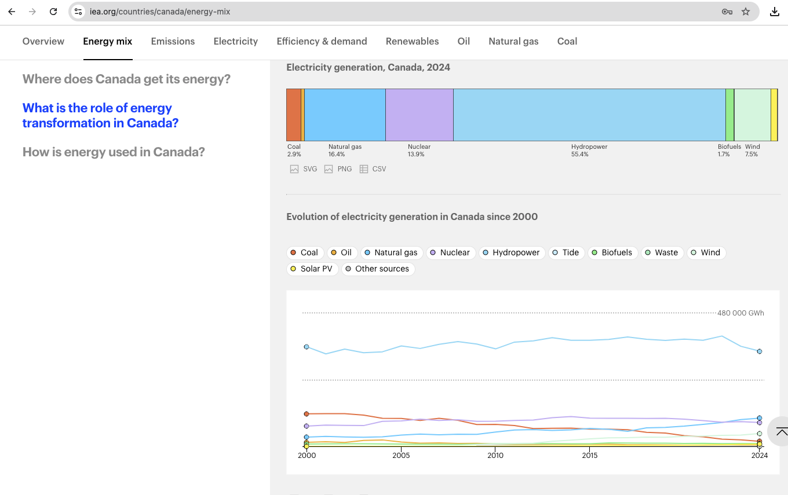

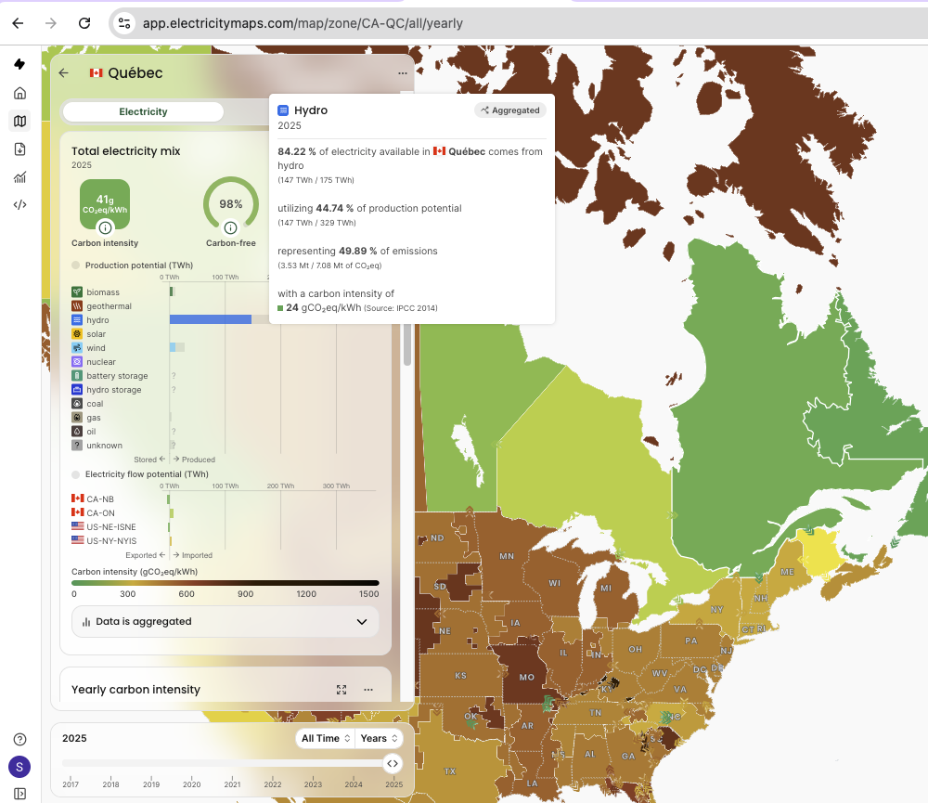

China – most updated 2023 electricity%
